**Practical No: 1**

**Study the process of creating graphical user interface.**

**➢ What is GUI?**

GUI design, or graphical user interface design, refers to the graphics of digital interfaces such

as computers and mobile devices. A GUI design utilizes elements such as text, icons and images, as well as components, to allow a user to navigate and interact with a GUI. For

instance, the graphics along the bottom bar of your laptop screen is a prime example of a

GUI.

Websites, mobile apps and web apps also use GUI designs to allow user interactions via

various graphics.

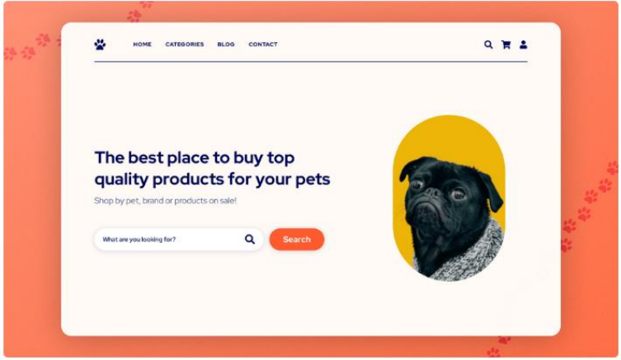

**➢ How does GUI design work?**

A GUI uses graphics to implement changes, and to allow control over a digital product,

website or app. With the graphical aspect of a GUI comes endless possibilities. A user can

click on buttons to take them to a new page, scroll through a list, type in input fields, toggle

settings on and off, and much more.

**➢ How to design a GUI?**

**Step 1: Wireframing your GUI design.**

The first step is to create basic wireframe screens for your project. You will need to know

how many design screens your project will consist of, and roughly the user flow between

screens. Sketch your GUI design by hand on a piece of paper, or digitally using a GUI design

tool. You don’t need to add loads of detail here, just placeholder outlines of elements and

components will suffice.

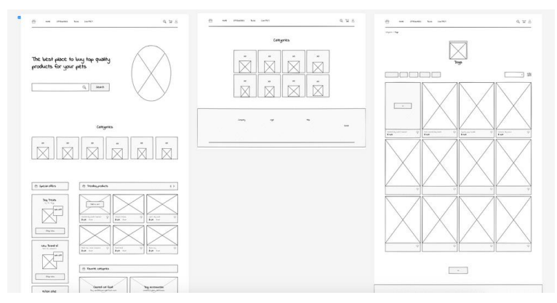

**Step 2: Designing a GUI mock up**

The next step is to add more detail to your GUI wireframe, and this will turn your wireframe

into a mockup. You will require a GUI design tool at this stage, and from here you can add

color, detailed elements such as images, and small sections of text.

Mockups are the second to last stage in the GUI design process, which makes them perfect

for gathering feedback. Ask friends, colleagues and clients to share their thoughts so you can

make edits to your GUI before the prototype stage.

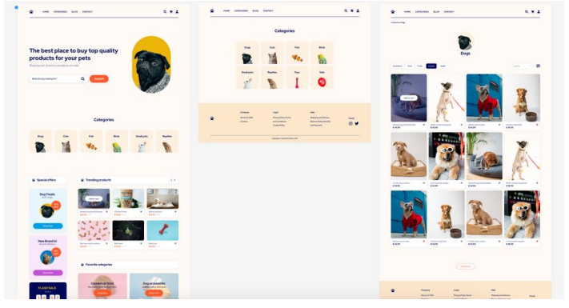

**Step 3: Create a GUI design prototype**

Now it’s time to bring your GUI design to life. Prototyping a GUI is one step further than

creating a mockup. Here you will map the user flow between your design screens, as well as

adding extra detail like blocks of text and extra design assets to really pull your design

together. User testing should be done at this stage to ensure that you have effectively mapped

the user journey between screens. Once you’re happy with your GUI design, you can

handover to a developer to make your design fully functional and interactive.

